BECE206P - Analog Circuits Lab

Name: **ANKIT NEGI**

Reg. No.: **22BEC1117**

Experiment No. & Title: **4 – Schmitt Trigger & Astable Multi-Vibrator using**

**Op-Amp**

**AIM:** To design and verify a Schmitt Trigger & Astable Multi-Vibrator using an Op-Amp.

**Components/Software required:** LTspice

**Procedure:**

1. Create the circuit for the Schmitt Trigger circuit by referring to the circuit diagram.
2. Input all the component values by right clicking on the components and simulate the circuit using DC op pnt to get the required DC output and verify the results.
3. 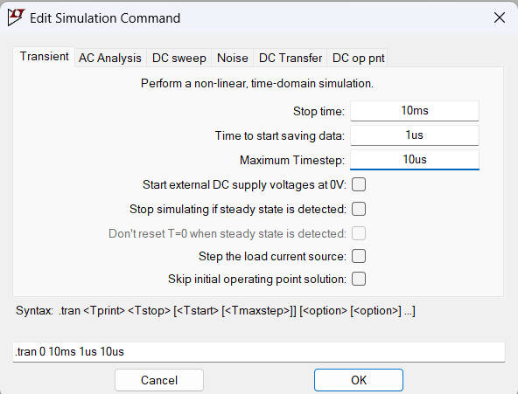Use edit simulation cmd to simulate the circuit using transient analysis with the required values:
4. Use “add plot panes” in the output window and use the jockey to probe on the input and output terminal to get the required transient analysis output.
5. Finally, construct the Astable Multi-Vibrator circuit using an op-amp by referring to the circuit diagram.
6. Right click on each component to enter the required values and ground the circuit.
7. Simulate the circuit using DC op pnt and Transient Analysis with previously used values to get the required output.

**Circuit Diagram:**

1. **Schmitt Trigger Circuit:**

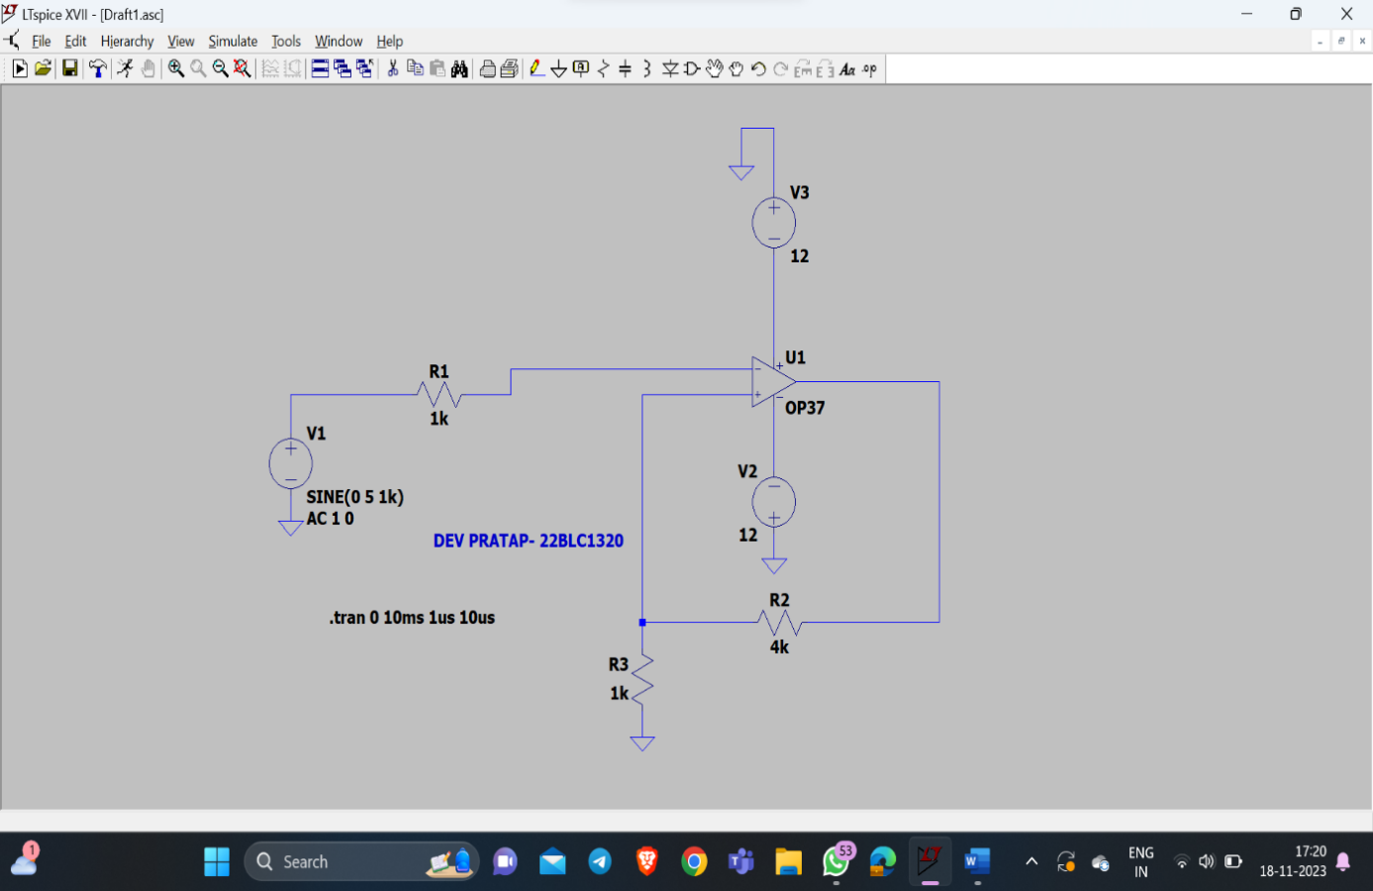

ANKIT NEGI[22BEC1117]

1. **Astable Multi-Vibrator using Op-Amp:**

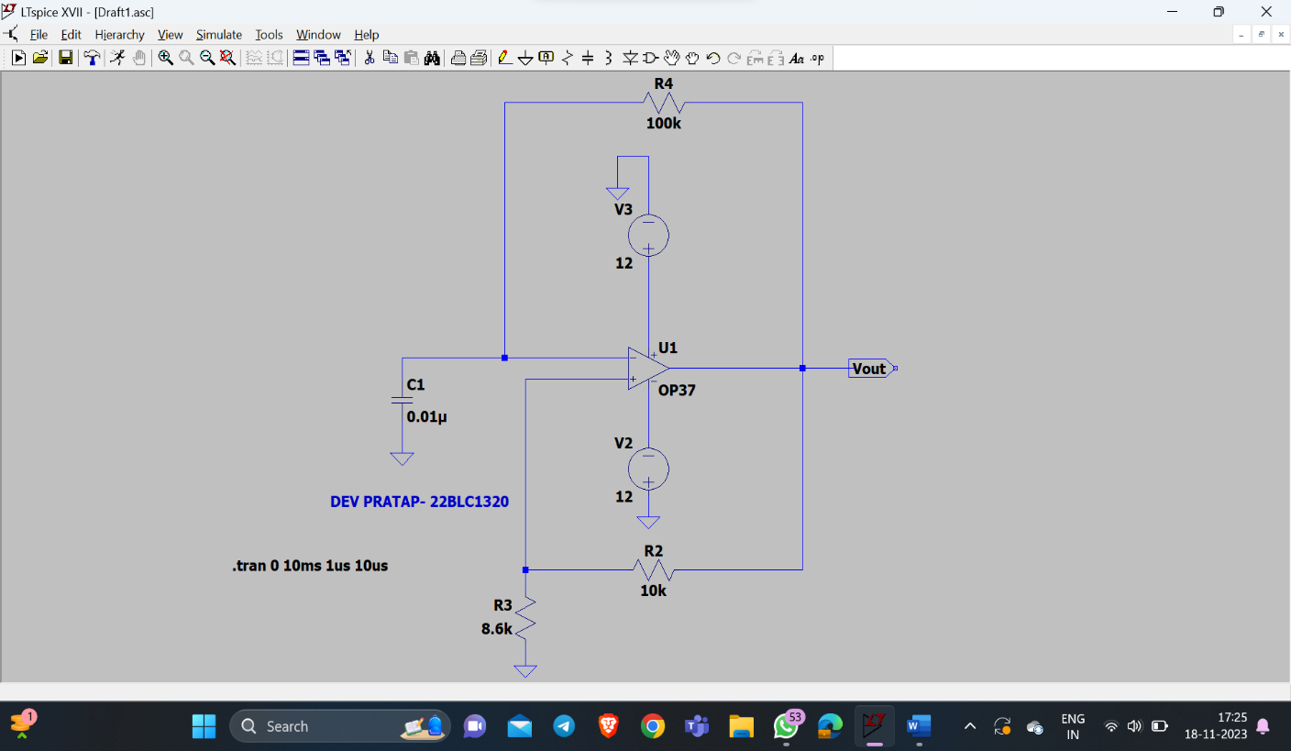

ANKIT NEGI[22BEC1117]

**Graph/ Simulated Outputs:**

# Schmitt Trigger Circuit:

* 1. **DC op pnt Output:**

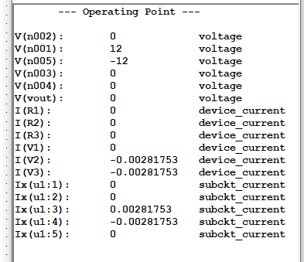

* 1. **Transient Analysis Output:**

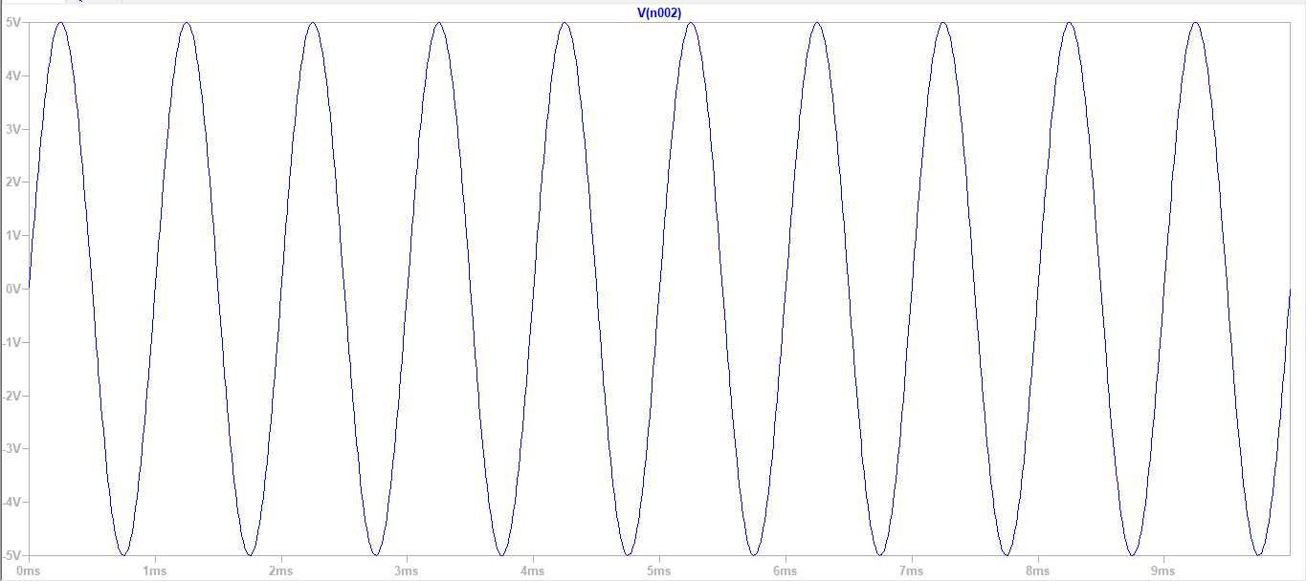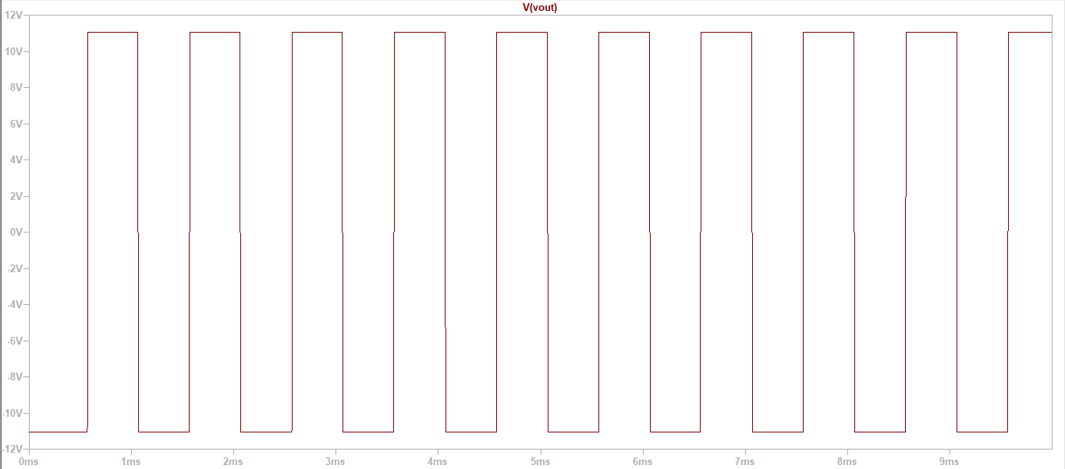

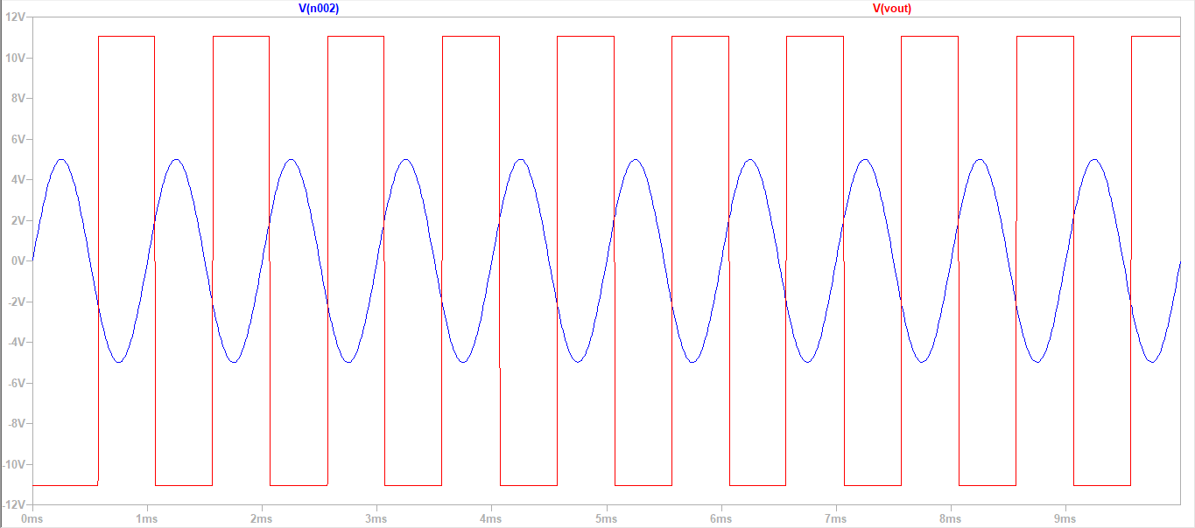

# Astable Multi-Vibrator using Op-Amp:

* 1. **DC op pnt Output:**

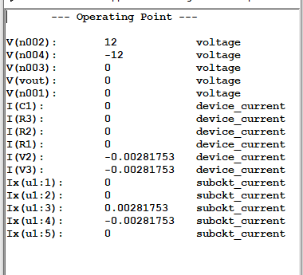

* 1. **Transient Analysis Output:**

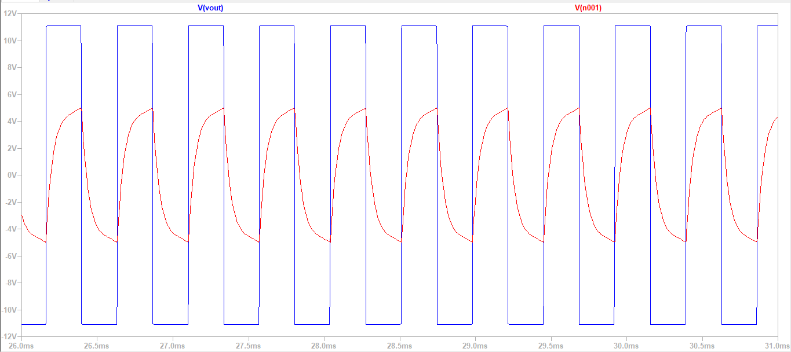

**Inference:**

1)A Schmitt Trigger is a type of comparator circuit that incorporates positive feedback. It is designed to convert an analog input signal into a digital output signal. The positive feedback creates hysteresis, which means the threshold levels for switching between high and low states are different. This feature makes the Schmitt Trigger less susceptible to noise and provides stable switching behavior. In essence, it acts as a signal conditioner, ensuring a clean and well-defined digital output.

2)An Astable Multi-vibrator is a type of oscillator that continuously generates a square wave output without the need for an external trigger. When an Op-Amp is used in the astable Multi-vibrator configuration, it takes advantage of the Op-Amp’s ability to amplify and invert signals. The circuit includes a feedback loop with resistors and capacitors, creating a timing mechanism that determines the frequency of the output waveform. This configuration essentially functions as a relaxation oscillator, with the Op-Amp driving the continuous oscillation by alternately charging and discharging the capacitor through the resistors.